**Market Segmentation Study Task**

(Vaibhav Kale)

**Abstract:**

Businesses may not be in a position to satisfy all of their customers, every time. It may prove difficult to meet the exact requirements of each individual customer. People do not have identical preferences, so rarely does one product completely satisfy everyone. Therefore, many companies may usually adopt a strategy that is known as target marketing. This strategy involves dividing the market into segments and developing products or services to these segments. A target marketing strategy is focused on the customers’ needs and wants. Hence, a prerequisite for the development of this customer-centric strategy is the specification of the target markets that the companies will attempt to serve. The marketing managers who may consider using target marketing will usually break the market down into groups (segments). Then they target the most profitable ones. They may adapt their marketing mix elements, including; products, prices, channels, and promotional tactics to suit the requirements of individual groups of consumers.

**The Market Segment**

A market segment is a group of individuals, groups or organizations who may share the same interests, traits and characteristics. The consumer segments may have similar needs, wants and expectations. Therefore, businesses should ask themselves which segments should they serve? To answer this question, the businesses must determine the most appropriate ways to distinguish and to differentiate their segments. Once the segments have been identified they must customize their offerings to satisfy each and every one of them.

**STEP - 1: Deciding (not) to Segment**

Market segmentation is the process where the wide range of customers are categorized as groups/clusters based on similarity criteria. Usually, business organizations who aim for catering to all sections of customers choose the market segmentation model. But now the question here is will the market segmentation model hold strong for all kinds of organizations and people working in them? This step explains some of the barriers for the model, only without which it is safe to exploit the market segmentation strategy. To maximize the benefits of market segmentation, organizations need to organize around segments rather than products. Points to consider for deciding whether or not to proceed with market segmentation are:

* Organization should be market-oriented
* It should be willing to adapt to constant changes and encourage new ideas
* It should be able to view the strategy as a long term plan
* An organization should have well established communication across all its units
* The organization should have sufficient financial resources in order to cater to all sections of customers
* Senior managers in the organization should be determined throughout the process, and have strong commitments and involvements
* Market segmentation as a concept should be fully understood otherwise the concerned teams should be well trained
* There should be no discrepancies in market segmentation analysts, and this is the job of the senior analysts
* Teams should consist of experts for marketing, data and analysis
* An organization should set up committees to represent all units
* A clear, structured process should be followed for market segmentation analysis



**STEP - 2: Specifying the Ideal Target Segment**

Market segmentation relies heavily on user input. This user input is not limited to negotiations at the start of the process or development of a marketing mix at the end of the process. The user must be involved in most stages of the technical aspects of market segmentation analysis. In this step the organization must determine two segment evaluation criteria - knock-out criteria and attractiveness criteria.

**KNOCK-OUT CRITERIA**

It is used to determine if market segments qualify to be assessed using segment attractiveness criteria. This criteria includes:

* Homogeneity
* Distinctness
* Size
* Match
* Identifiability
* Reachability of the segments.

The market segments which don’t comply with these points can be automatically eliminated. The knock-out criteria must be understood by senior management, the segmentation team itself and the advisory committee of step-1.

**ATTRACTIVENESS CRITERIA**

The attractiveness across all criteria determines whether a market segment is selected as a target in market segmentation analysis. The available criteria for assessment of market segment attractiveness should be individually studied. These criteria should be discussed with fellow team members of the segmentation team and six criteria should be finalised. Certain points should be distributed to these six criteria in a way that reflects the relative importance of each of the attractiveness criteria. The weights assigned should be negotiated with the segmentation team to draw a conclusion. The final selected segment attractiveness criteria and corresponding weights need to be presented to the advisory committee for discussions, if required.

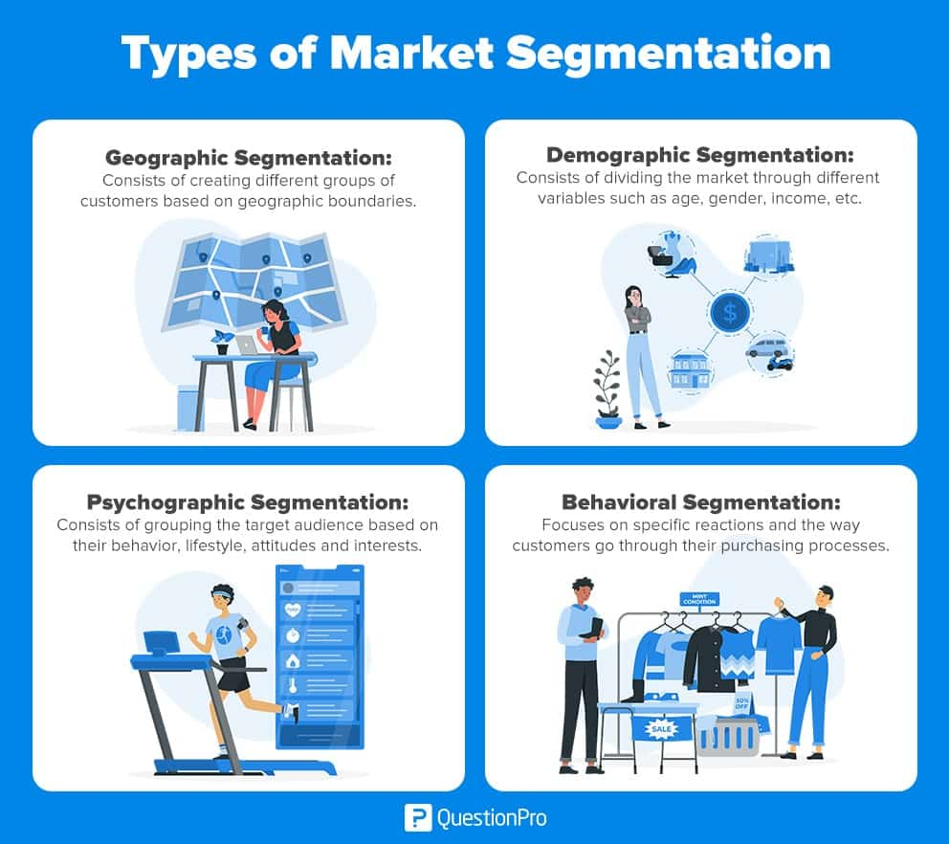

**STEP - 3: Collecting Data**

Empirical data has a major contribution for the success of market segmentation (both common sense and data-driven wise). High quality empirical data is necessary for building a valid segmentation solution. A segmentation variable is that variable in the empirical data which is used in segmentation to split the sample into market segments. In common sense segmentation this is usually only one characteristic/feature of the consumers in the sample while in data-driven market segmentation it is a set of multiple features in general. The variables apart from the segmentation variables are known as descriptor variables which are used to describe the segments in more detail. Descriptionof segments is critical for developing a marketing mix targeting the segments. The term segmentation criterion is broader than the segmentation variable. While the segmentation variable refers to one measured value, segmentation criterion on the other hand relates to the nature of information used for market segmentation. The differences between consumers that are the most relevant in terms of market segmentation are:

* Profitability
* Bargaining power



The most common segmentation criteria are as follows:

● **Geographic Segmentation** - It is seen as the original segmentation criterion for market segmentation. Here, the consumer’s location of residence serves as the only criterion to form market segments. The key advantage of geographic segmentation is that each consumer can easily be assigned to a geographic unit which implies that it would be easy to target communication messages, select communication channels, etc.. to reach the selected geographic segments. The disadvantage is that living in the same area doesn’t necessarily mean that people share other characteristics relevant to the marketers

● **Socio-Demographic Segmentation -** Typical socio-demographic segmentation criteria include age, gender, education and income. It has the advantage of segment membership being determined for every consumer. But often, the sociodemographic criterion is not the cause for product preferences, thus not providing sufficient market insights for optimal segmentation decisions

**● Psychographic Segmentation - These majorly include people’s beliefs, interests, preferences, aspirations, benefits sought when purchasing a product, etc.. The psychographic approach has the advantage that is generally more reflective of underlying reasons for differences in consumer behaviour. The disadvantage is that this approach has an increased complexity of determining segment memberships for consumers and that its power depends heavily on reliability of empirical measures used to capture psychographic dimensions of interest**

**● Behavioural Segmentation - Here, similarities in behaviour can directly be searched. The possible behaviours include prior experience with the product, frequency of purchase, amount spent on purchasing the product on each occasion and information search behaviour. It emerged as superior to the geographic variables. The key advantage of behavioural approaches is that, if based on actual/recorded behaviour rather than stated behaviour, the very behaviour of interest is used as the basis of segment extraction**

**Step 4: Exploring Data**

* Data Collection: Start by collecting relevant data from various sources, such as market research studies, surveys, customer databases, industry reports, and internal sales data. The data should cover demographic information, purchasing behavior, psychographics, geographic factors, and any other relevant variables.
* Data Cleaning and Preparation: Once the data is collected, it needs to be cleaned and prepared for analysis. This involves removing duplicates, correcting errors, handling missing values, and transforming data into a suitable format for analysis.
* Descriptive Analysis: Conduct descriptive analysis to understand the basic characteristics of the data. This can include calculating summary statistics, creating frequency distributions, and visualizing data through charts, graphs, and tables. Descriptive analysis helps identify patterns, trends, and outliers in the data.
* Exploratory Data Analysis: Dive deeper into the data through exploratory data analysis (EDA) techniques. EDA involves using statistical methods and data visualization to uncover relationships, associations, and insights within the data. Techniques like scatter plots, histograms, correlation analysis, and clustering can be employed to identify potential segments and patterns.
* Variable Selection: Identify the most relevant variables that can differentiate market segments effectively. This can be done through statistical tests, domain knowledge, or expert opinions. Selecting the right variables is crucial for segmenting the market accurately.
* Segment Profiling: Use the explored data to create profiles for each potential market segment. This involves analyzing the characteristics, preferences, behaviors, and needs of different segments. It helps in understanding the distinct attributes of each segment and their potential value to the organization.

**Data cleaning**

Data cleaning, also known as data cleansing or data scrubbing, is a crucial process in preparing data for analysis. It involves identifying and correcting or removing errors, inconsistencies, and inaccuracies in the data to ensure its quality and reliability. Here are some key steps involved in data cleaning:

* Handling Missing Values: Identify missing values in the dataset and decide on the appropriate approach for handling them. Options include removing records with missing values, imputing values using statistical methods (e.g., mean, median, or regression imputation), or using advanced imputation techniques.
* Removing Duplicates: Identify and remove duplicate records from the dataset. Duplicate records can distort analysis results and lead to incorrect insights. Common approaches include comparing records based on key identifiers or using similarity measures.
* Correcting Inaccurate or Inconsistent Data: Identify and correct any inaccuracies or inconsistencies in the data. This can involve standardizing formats, resolving inconsistent spellings or naming conventions, and addressing data entry errors.
* Validating Data Integrity: Validate the integrity of the data by ensuring that it adheres to predefined rules or constraints. This may involve checking for outliers, range violations, or logical inconsistencies.
* Handling Outliers: Identify and handle outliers in the data. Outliers are data points that significantly deviate from the expected patterns or distributions. Depending on the context, outliers can be treated by removing them, transforming them, or considering them as a separate segment.
* Standardizing and Normalizing Data: Standardize and normalize data to ensure consistency and comparability. This involves transforming variables into a common scale or format. For example, converting categorical variables into numerical representations or scaling continuous variables.

**Descriptive analysis**

Descriptive analysis is a preliminary step in data analysis that focuses on summarizing and describing the main characteristics of a dataset. It helps in gaining a better understanding of the data and identifying patterns, trends, and key insights. Here are some common techniques used in descriptive analysis:

* Measures of Central Tendency: Calculate measures such as the mean, median, and mode to understand the average or typical value of a variable. The mean represents the average value, the median represents the middle value, and the mode represents the most frequently occurring value.
* Measures of Dispersion: Determine the spread or variability of data using measures such as the range, variance, and standard deviation. The range is the difference between the maximum and minimum values, while the variance and standard deviation quantify the average deviation of data points from the mean.
* Frequency Distribution: Create a frequency distribution table or histogram to visualize the distribution of a categorical or continuous variable. This helps in understanding the frequency or occurrence of different values or groups within the dataset.
* Cross-tabulation: Analyze the relationship between two categorical variables using a cross-tabulation or contingency table. This provides insights into the distribution and association between different categories.
* Charts and Graphs: Utilize various visual representations, such as bar charts, line graphs, pie charts, or scatter plots, to present and summarize data. Visualizations make it easier to grasp patterns, trends, and comparisons within the dataset.
* Percentiles: Calculate percentiles to identify specific points in the data distribution. Percentiles indicate the value below which a certain percentage of data falls. For example, the 75th percentile represents the value below which 75% of the data points lie.

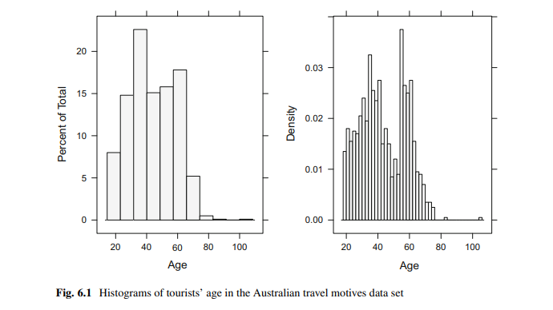

**Pre-processing**

Pre-processing, also known as data preprocessing, is a crucial step in data analysis that involves preparing and transforming the data to make it suitable for further analysis and modeling. Here are some common tasks involved in pre-processing:

* Data Cleaning: As mentioned earlier, data cleaning involves handling missing values, removing duplicates, correcting inaccuracies, and dealing with outliers. This step ensures that the data is accurate and reliable for analysis.
* Data Integration: If you have data from multiple sources, data integration involves combining and merging the data into a single dataset. This step ensures that all relevant information is included in the analysis.
* Data Transformation: Data transformation involves converting variables into a suitable format for analysis. This may include standardizing units of measurement, scaling variables, or transforming variables to follow a specific distribution (e.g., logarithmic or exponential transformations).
* Feature Selection: Feature selection involves identifying and selecting the most relevant variables or features that contribute to the analysis task. Removing irrelevant or redundant features can simplify the analysis and improve model performance.
* Feature Encoding: If your dataset includes categorical variables, feature encoding is necessary to represent them in a numerical format. Common encoding techniques include one-hot encoding, label encoding, or ordinal encoding.
* Dimensionality Reduction: In cases where the dataset has a large number of features, dimensionality reduction techniques like Principal Component Analysis (PCA) or t-distributed Stochastic Neighbor Embedding (t-SNE) can be used to reduce the number of variables while preserving important information.
* Data Discretization: Data discretization involves dividing continuous variables into discrete intervals or bins. This can be useful in cases where the analysis or model requires categorical variables or when dealing with skewed data distributions.

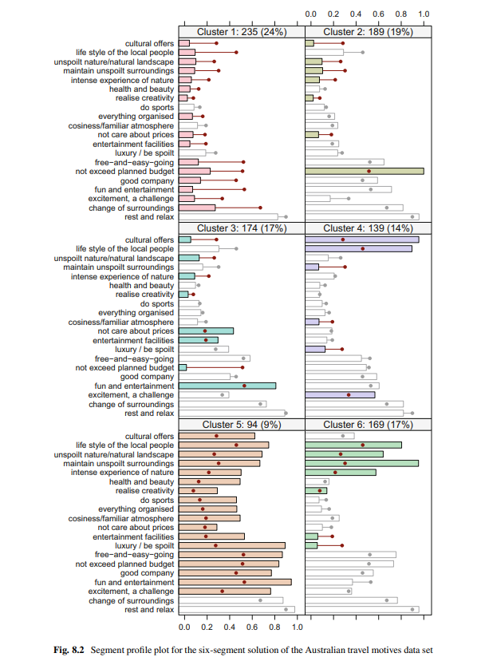

**Step – 6 : Profiling Segments**

**Identifying Key Characteristics of Market Segments :**

The aim of this step - profiling segments is to get to know the generated segments from the extraction step. Profiling consists of characterising the market segments individually, but alsoin comparison to the other market segments.

**Segment Profiling with Visualisations :**

Demonstrating the segmented customers visually is considered as a much better alternativeto long explanations. They are much easier to interpret and process and finally make criticaldecisions. A segment profile plot is used to understand the defining charactersticks of each segment. Itis also called a panel-plot. Each panel represents a segment. For each segment, the segment profile plot shows the cluster centres (centroids, representatives of the segments).An example of a panel plot is shown below :

Different panel and different segment have different centroids and distributions representingdifferent kind of customers prioritizing different motives for travelling.

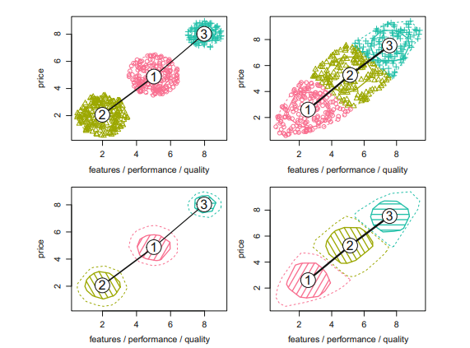

The graphs on the RHS are closely packed because two datasets are used in their segmentation. To avoid this problem we can perform principal component analysis whichreduces multiple dimensions to a smaller number of dimensions.

**Feynn Labs - Market Segmentation Study Task**

**GitHub Link**

**1. https://github.com/vaibhavkale07/Market-Segmentation-Analysis-on-McDonalds-Data**